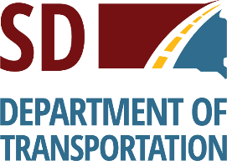
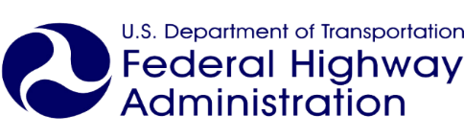


Certificate of Completion
to
NAME
for successfully completing the
SD Roads 2 Jobs
Career Awareness Training
on April 8, 2019.

_____________________________________________
Presenter Signature



