**Wetland Mitigation**

**Registry Form**

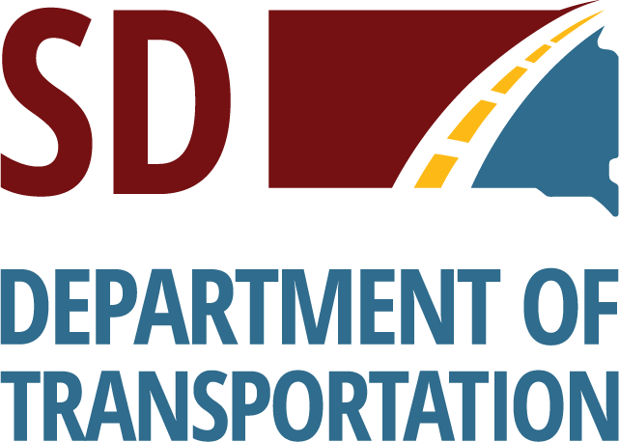

Federal regulations require that unavoidable wetland impacts caused by highway construction be mitigated. Examples of acceptable wetland mitigation include 1) wetland creation; 2) wetland restoration – plugging an existing, drained wetland; or, 3) by wetland enhancement - adding buffer around an existing wetland.

The South Dakota Department of Transportation (SDDOT) may participate in the cost of wetland creation/restoration/enhancement, if the wetland can be used to mitigate wetland impacts caused by highway construction.

If you are interested in creating, restoring, or enhancing wetlands on your property, please complete the attached form and mail to: Kit Bramblee, Environmental Scientist Manager, SDDOT, 700 E. Broadway Ave., Pierre, SD. 57501. Your name will be added to the SDDOT Wetland Mitigation Registry and a SDDOT representative will contact you with additional information.

**Yes, I am interested in assisting the SDDOT to mitigate wetland impacts by creating or restoring wetlands on my property.**

***Name:***

***Address:***

***Phone #: Email:***

***Legal Description of property: 1/4 of Section***

***Township , Range , County***

***Please note*: Completion of this form does not commit either you or the SDDOT to a mitigation project. It is a statement of intent only**.