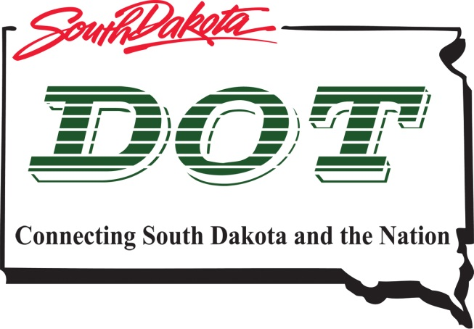 | South Dakota Department of  Transportation
Public Meeting on
Proposed Project to
Reconstruct SD Hwy 50 and
US HWYS 18 & 281
(From Wagner to Douglas County Line)
Tuesday, January 17th, 2017
5:30pm—6:30pm
Wagner Theater, 218 Main Ave South
Wagner, SD
Public is encouraged to attend

Public Meeting Information @
http://sddot.com/dot/publicmeetings/default.aspx

Any individuals with disabilities who will require a reasonable accommodation in order to participate
in the public meeting should submit a request to the department’s ADA Coordinator at
605-773-3540 or 1-800-877-1113 no later than 2 business days prior to the meeting

