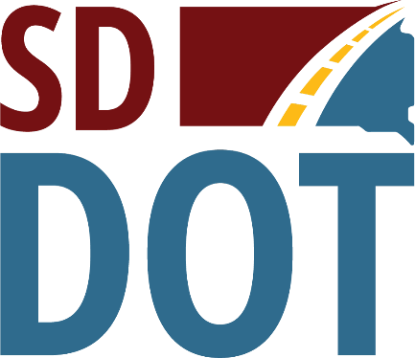 | South Dakota  Department of  Transportation

Open House/Public Meeting for
the Proposed S.D. Highways 10 and 1804 - Through Pollock ADA Upgrades & Sidewalk project
Tuesday, March 12, 2024
5:30 p.m. to 6:30 p.m.
Pollock School and Community Center
916 F Ave.
Pollock, SD 57648
Public is encouraged to attend.
Public Meeting Information @
https://dot.sd.gov/projects-studies/projects/public-meetings#listItemLink_1971

