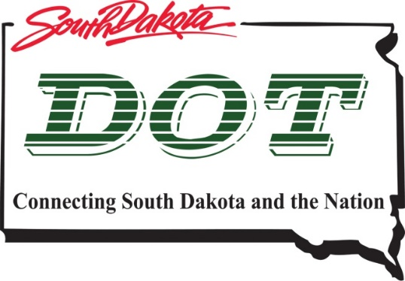 | South Dakota  Department of  Transportation

The SDDOT is proposing to reconstruct SD. Highway 13 from SD. Highway 324 to US Highway 14 in 2023. An in-person public meeting will not be held at this time. Interested parties are invited to view the public meeting documents online at the link below and provide comments if desired.
Question or Comments should be submitted by December 28, 2020 by Email to: Michael.Jacobson@State.SD.US or by US Mail at:
Michael Jacobson
5316 W 60th Street North
Sioux Falls, SD 57107
Ph:605-367-4970 Ext. 1802140

Public Meeting Information @
https://dot.sd.gov/projects-studies/projects/public-meetings
(Aberdeen Region)

