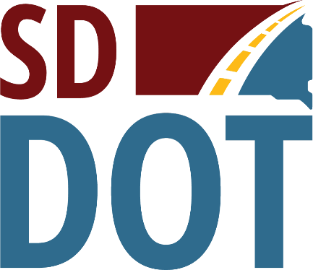 | South Dakota  Department of  Transportation

Open House/Public Meeting for
Proposed Project to
Reconstruct S.D. Highway 15
(SD Highway 15 from Clear Lake north to U.S. Highway 212)
Thursday, June 29, 2023
5:30 p.m. to 6:30 p.m.
Clear Lake Community Center
218 3rd Ave. S., Clear Lake, SD 57226
Public is encouraged to attend
Public Meeting Information @
https://dot.sd.gov/projects-studies/projects/public-meetings#listItemLink_1901

