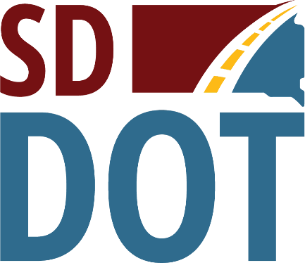 | South Dakota  Department of  Transportation

Open House/Public Meeting for
Proposed Project to
Reconstruct S.D. Highway 37
(through Parkston)
Tuesday, July 18, 2023
5:30 p.m. to 6:30 p.m.

Parkston Emergency Services
309 East Main St., Parkston, SD
Public is encouraged to attend
Public Meeting Information @
https://dot.sd.gov/projects-studies/projects/public-meetings#listItemLink_1920

