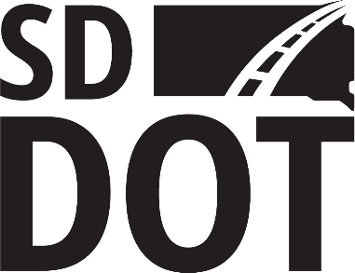

SOUTH DAKOTA DEPARTMENT OF TRANSPORTATION

Disadvantaged Business Enterprise Program

Annual Affidavit – Out-of-State Firms

1. | Legal name of firm
2. | Address
Street City St Zip
3. | Mailing Address (if different from above )
4. | Business Phone Number |  |  |  |  |  |  |  | Fax Number
5. | Email Address
6. | Name of Disadvantaged Owner
7. | Name of person(s) who prepared this application

* Describe the primary activities of your firm.

* Note: If your primary line of work is trucking, attach a list of all tractors, trailers and dump trucks owned and all tractors, trailers and dump trucks leased.

Describe area of South Dakota that you are willing to work:

INSTRUCTIONS

Complete this form and attach documentation showing the firms size and gross receipts (e.g. firm’s most current federal tax returns) and a copy of your current home-state certification. The completed annual affidavit and proof of home state certification must be returned by your current certification renewal date to:

DBE Program
South Dakota Department of Transportation
700 E Broadway Ave
Pierre, SD 57501-2586
Annual No Change Affidavit
Disadvantaged Business Enterprise Program

I, ___________________, swear (or affirm) that there have been no changes in (DBE firm) circumstances affecting its ability to meet the size, disadvantaged status, ownership, or control requirements of 49 CFR Part 26 and 13 CFR Part 121. I swear (or affirm) there have been no material changes in the information provided in the Disadvantaged Business Enterprise program application for certification, except for any changes about which I have provided written notice to the South Department of Transportation, Disadvantaged Business Enterprise program pursuant to 49 CFR § 26.83(i).

I swear (or affirm) that I am socially disadvantaged because I have been subjected to racial or ethnic prejudice or cultural bias, or have suffered the effects of discrimination, because of my identity as a member of one or more of the groups identified in 49 CFR § 26.5, without regard to my individual qualities.

I further swear (or affirm) that my personal net worth does not exceed $1.32 million, and that I am economically disadvantaged because my ability to compete in the free enterprise system has been impaired due to diminished capital and credit opportunities as compared to others in the same or similar line of business who are not socially and economically disadvantaged.

I specifically swear (or affirm) that _______________________________ (name of firm) continues to meet the Small Business Administration (SBA) business size criteria and the overall firm’s previous five fiscal years gross receipts in excess of $30.40 million in regards of 49 CFR §26.65(b).

I AM PERSONALLY AUTHORIZED AS THE OWNER OF, , TO MAKE THIS AFFIDAVIT.

Date: Signature:

NOTARIZATION
Official notary of the public to complete the following:

On this, the day of , 20 , before me a notary public undersigned officer, personally appeared , known to me (or satisfactory proven) to be the person
Name of Affiant
whose name is subscribed to the within instrument and acknowledged that he or she executed the same in the capacity therein stated, for the purposes therein contained and that the statements contained therein are true and correct.
IN WITNESS HEREOF, I HEREUNTO SET MY HAND AND OFFICIAL SEAL

Notary Public
Seal

Notary Public

Commission expiration date

