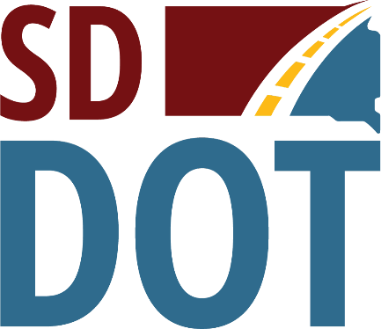 | South Dakota  Department of  Transportation

Open House/Public Meeting for
Proposed Project to
Reconstruction of S.D. Highway 44 Bridge
(Near Cliffside Park, four miles West of Highway 231 Junction)
Tuesday, Oct. 25, 2022
5:30 p.m. to 7 p.m.
Canyon Lake Activity Center
2900 Canyon Lake Drive, Rapid City
Public is encouraged to attend
Public Meeting Information @
https://dot.sd.gov/projects-studies/projects/public-meetings#listItemLink_1822

