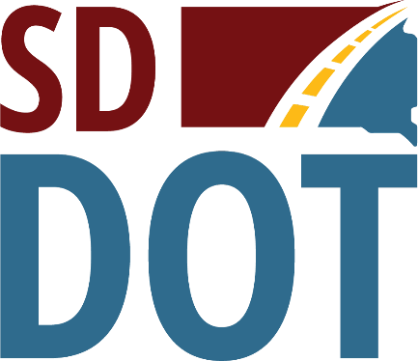 | South Dakota  Department of  Transportation

Public Meeting for
Proposed Project to
Reconstruct U.S. Highway 85
(7 Miles north of Buffalo to Ludlow)
Thursday, February 16, 2023
5:30 pm to 7:30 pm
Harding County Community Center
204 Hodge St, Buffalo, SD
Public is encouraged to attend
Public Meeting Information @
https://dot.sd.gov/projects-studies/projects/public-meetings#listItemLink_1874
(Rapid City Region)

