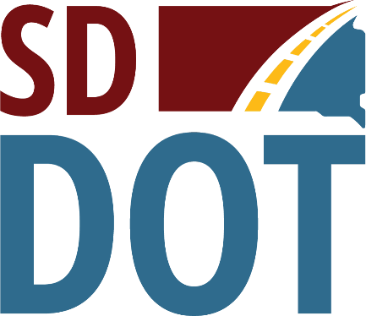 | South Dakota  Department of  Transportation

Open House/Public Meeting for
Proposed Project to
Reconstruct S.D. Highway 37
(From S.D. Highway 28, south 12 miles)
Tuesday, Oct. 4, 2022
5:30 pm to 6:30 p.m.
Crossroads Hotel
100 4th St. SW, Huron, SD
Public is encouraged to attend
Public Meeting Information @
https://dot.sd.gov/projects-studies/projects/public-meetings#listItemLink_1806

